
UNIVERSITY COLLEGE DUBLIN
An Coláiste Ollscoile Baile Átha Cliath

UCD SCHOOL OF NURSING, MIDWIFERY & HEALTH SYSTEMS
Scoil na hAltrachta, an Cnáimhseachais agus na gCoras Slainte


In partnership with
Saint John of God University Hospital and
HSE Dublin South and Wicklow


Medication Workbook for Year 2 & 3

BSc Mental Health Nursing Students

Student Number:
Student Name:
Introduction
This workbook has been developed as a tool to assist you in gaining knowledge of some of the commonly used medications during your practice placements in Stage 2 and Stage 3 of your Mental Health Nursing programme. In Stage 1 and Stage 2 you received lectures and clinical skills in UCD relating to pharmacology and medication administration and professional practice to assist you to link theory to practice. Medication administration and professional practice is an important aspect of your National Competency Assessment Document (NCAD) Assessment and the Domains and Standards specific to this area are detailed in the table below:

Table 1: Domains and Performance Indicators that pertain to Medication Management Stage 2 Mental Health Nursing Practice Placement

*2.3[h]: Assists the Registered Nurse in the safe administration and management of medicines
3.1[c]: Safely and accurately carries out medication calculations and management with particular regard to the vulnerability of persons in receipt of healthcare

Stage 2: This level recognises the undergraduate nursing student as an advanced beginner and has participation (student participates rather than an observer) and identification (nursing student takes responsibility for their own learning) under close supervision from preceptor or staff nurse (close supervision = presence or close proximity to the undergraduate student)
Table 2: Domains and Standards that pertain to Medication Management Stage 3 Mental Health Nursing Practice Placement
Domain 1 | Domain 2 | Domain 3 | Domain 4 | Domain 5 | Domain 6
1.1 | 2.1 [d]* | 3.1[c]* | 4.1 | 5.1 | 6.1
1.3 | 2.2 | 3.2 | 4.2 | 5.2 | 6.2
 | 2.3
 | 2.4

Stage 3: This level recognises the undergraduate nursing student as an advanced beginner and has participation (student participates in patient care with support) and identification (nursing student takes responsibility for their own learning) under indirect supervision from preceptor or staff nurse (indirect supervision = preceptor is accessible to the undergraduate student nurse for guidance and support)
*2.1[d]: Integrates knowledge of pathophysiology and pharmacotherapeutics into the assessment of a person
3.1[c]: Safety and accurately carries out calculations for medication management, including intravenous infusions where appropriate

Medication Workbook for Stage 2 & 3 BSc Mental Health Nursing

 | Name/Date | Case study Completed Please Tick |  |  | Name/Date | Case study Completed Please Tick
Placement 1: |  |  |  | Placement 1:
Placement 2: |  |  |  | Placement 2:
Placement 3: |  |  |  | Placement 3:
Placement 4: |  |  |  | Placement 4:
Placement 5: |  |  |  | Placement 5:
Placement |  |  |  | Placement
Placement |  |  |  | Placement

Stage 2 Practice Placements Stage 3 Practice Placements

SIGNATURE BANK
Each registered midwife/nurse who acts as a preceptor/co-preceptor for this student must sign this signature bank.

Preceptors/Co-preceptor Name (Print) | Signature | Preceptors/Co- preceptor Initials | Ward/Area

SIGNATURE BANK
Each registered midwife/nurse who acts as a preceptor/co-preceptor for this student must sign this signature bank.

Preceptors/Co-preceptor Name (Print) | Signature | Preceptors/Co- preceptor Initials | Ward/Area

Learning Outcomes
In relation to medication management within your NCAD Document during your Stage 2 & Stage 3 clinical placements you will be expected to:
- Summarise Nursing and Midwifery Board of Ireland (NMBI) practice standards used for medication administration (NMBI 2018, in press)
- Summarise NMBI Code of Professional Conduct and Ethics for Registered Nurses and Registered Midwives (NMBI 2014).
- Identify and explain the 10 ‘Rights’ (R’s) of Medication Administration (NMBI 2018, in press; HIQA, 2015)
- Demonstrate an understanding of the local policies and procedures for medication management (including controlled drugs)
- Demonstrate competent hand hygiene techniques (e.g. hand washing; use of alcohol gel)
- Identify and demonstrate a knowledge of the emergency trolley medications
- Discuss how medications are prescribed (e.g. On prescription record/sheet, discharge prescription pad, electronic records)
- Discuss the steps involved in the safe administration of medication
- Participate in the correct practice of checking right patient, right reason, right drug, right route, right time, right dose (including calculations), right form, right action, right documentation, right response (NMBI, 2018; HIQA, 2015)
- Participate in the calculation, preparation and double checking of medications including the identification of patients/clients and the administration of medications and explain rationale for this
- Differentiate the types of storage for medications in the clinical area
- Identify the medications used in core and specialist areas

Additional Learning Outcomes specific to this placement:

Instructions for Use:

Part 1: | In addition to meeting these learning outcomes you will complete Part 1 of the workbook below in relation to medication management. You will be expected to identify the medications used in specialist areas (e.g. A minimum of 3 medications for each core placement and a minimum of 2 medications for each specialist placement.
Part 2: | You will be expected to understand the management of anaphylaxis in relation to adverse drug reaction
Part 3: | You will be expected to demonstrate the ability to perform drug calculations and answer the questions in relation to each of the listed medications.
Part 4: | You will be expected to use a case study approach to demonstrate knowledge of the different medications used in the specialist areas. (A total of 4 case studies in Stages 2&3 inclusive of medical placement). One of these case studies must be  completed on your longer placements. Please discuss the choice of placement and the patient with your preceptor and/or your CPC)

Medication Name | This refers to the approved (Generic) name of the medication, which is the name that must be used when the medication is prescribed
Brand/Trade Name | It is common to hear or see medications referred to by their brand name e.g. Panadol for paracetamol. It is important to be aware of the brand and generic name of medications
Medication Group | What group does the medication belong to? Is it an analgesic, antidepressant, antipsychotic, antibiotic?
Indication | Why is this medication used and for which condition and/or symptoms?
Dose | Doses may vary depending on weight, age, route used or the indications for use.
Route | How should the medication be administered e.g. orally, rectally, intravenously, inhalation, intramuscularly, subcutaneously
Frequency | How often should this medication be administered? What is meant by a ‘regular prescription’ and a prescription that is ‘PRN’? Where possible include the maximum dose in a 24-hour period or highlight the differences in frequency depending on route used.
Peak Action/Duration of Action | For example, if analgesia has been administered, how long will it take to work and how long will it last in the patients/client’s system?
Contraindications/Cautions | It is important to identify contraindications and cautions – can you explain the difference between these concepts?
Side-Effects | When you know the side-effects, you can identify the reason quickly and prevent or manage the side-effect in an effective manner
Observed administration of medication | Indicate if you have been involved in observing the administration of the stated medication
Participate under direct supervision in preparation, calculation, administration and  documentation of medication | Indicate if you have participated under direct supervision in the preparation, calculation, administration and documentation of medication
The following explains the requirements for each section of the workbook that you are required to complete on each placemen
The nurse who is administering the medicines must adhere to the ten rights of medication administration when administering medications to the patients in their practice placements see Guidance for Registered Nurses and Midwives on Medication Administration (NMBI, 2020): These are
- Right Patient: Be certain of the identity of the patient to whom the medicine is being administered by verifying the identification wristband, photograph or name and date of birth on the medicine chart.
- Right Reason: Understand the intended purpose of the medicines to be administered
- Right Drug: Confirm that the name of the dispensed medicine to be administered corresponds with the generic or brand name of the prescribed medicine, and they must only administer a viable medicinal product – that is, properly packaged and within its expiry date. The nurse must also check, both by asking the patient and inspecting the allergy status box on the medicines chart, whether the patient has a known and recorded allergy to the prescribed drug or no known allergies. The allergy box must be completed.
- Right Route: Administer the medicine via the prescribed anatomical route and site.
- Right Time: Administer the medicine at the prescribed time and prescribed intervals.

- Right Dose: Confirm, through arithmetical calculation that the dose of the medicine being administered concurs exactly with the dose prescribed. Where the local Policies, Procedures, Protocols and Guidelines (PPPGs) identify this process for high risk medicines, the dose must be independently verified.
- Right Form: Confirm that the form of medicine that has been dispensed matches with the specified route of administration.
- Right Action: Ensure the medicine is prescribed for the appropriate reason and state to the patient the action of the medicine and why it is prescribed.
- Right Documentation: Sign, date and retain all documentation recording the administration of each medicine in the medicine’s administration chart (or other document directing the administration of a medicine). The chart must only be signed to record a medicine has been administered once the medicine administration has been witnessed.
- Right Response: Observe the patient for adverse effects, and assess the patient to determine that the desired effect of the medicines has been achieved

*The information you require can be obtained from a number of sources including: www.medicines.ie which contains accurate, up to date, regulator approved information on medicines available in Ireland (Medicines.ie, 2019), The Irish Medicines Formulary, British National Formulary, Hospital Formulary, the hospital/community pharmacist, doctors, nursing/midwifery colleagues, articles, local policies and guidelines and NMBI guidelines

Always refer to the local Medication Policy for Medication Administration and Management

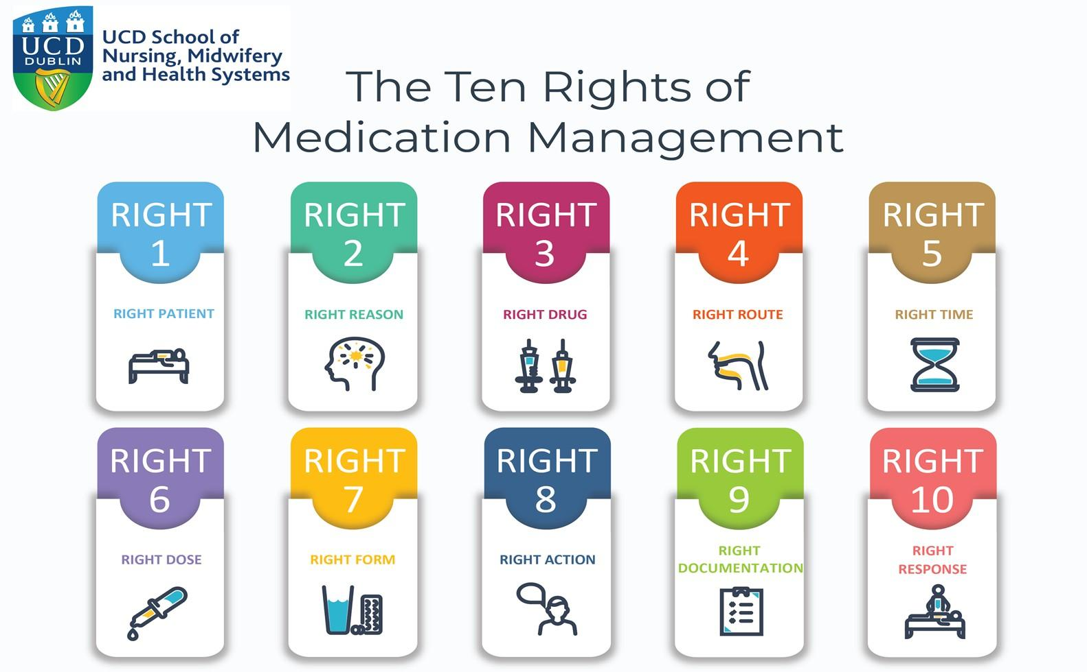
Domain 1 | Domain 2 | Domain 3 | Domain 4 | Domain 5 | Domain 6
1.1 | 2.1 | 3.1[c]* | 4.1 | 5.1 | 6.1
1.2 | 2.2 | 3.2 | 4.2 | 5.2 | 6.2
1.3 | 2.3 [h]*
 | 2.4

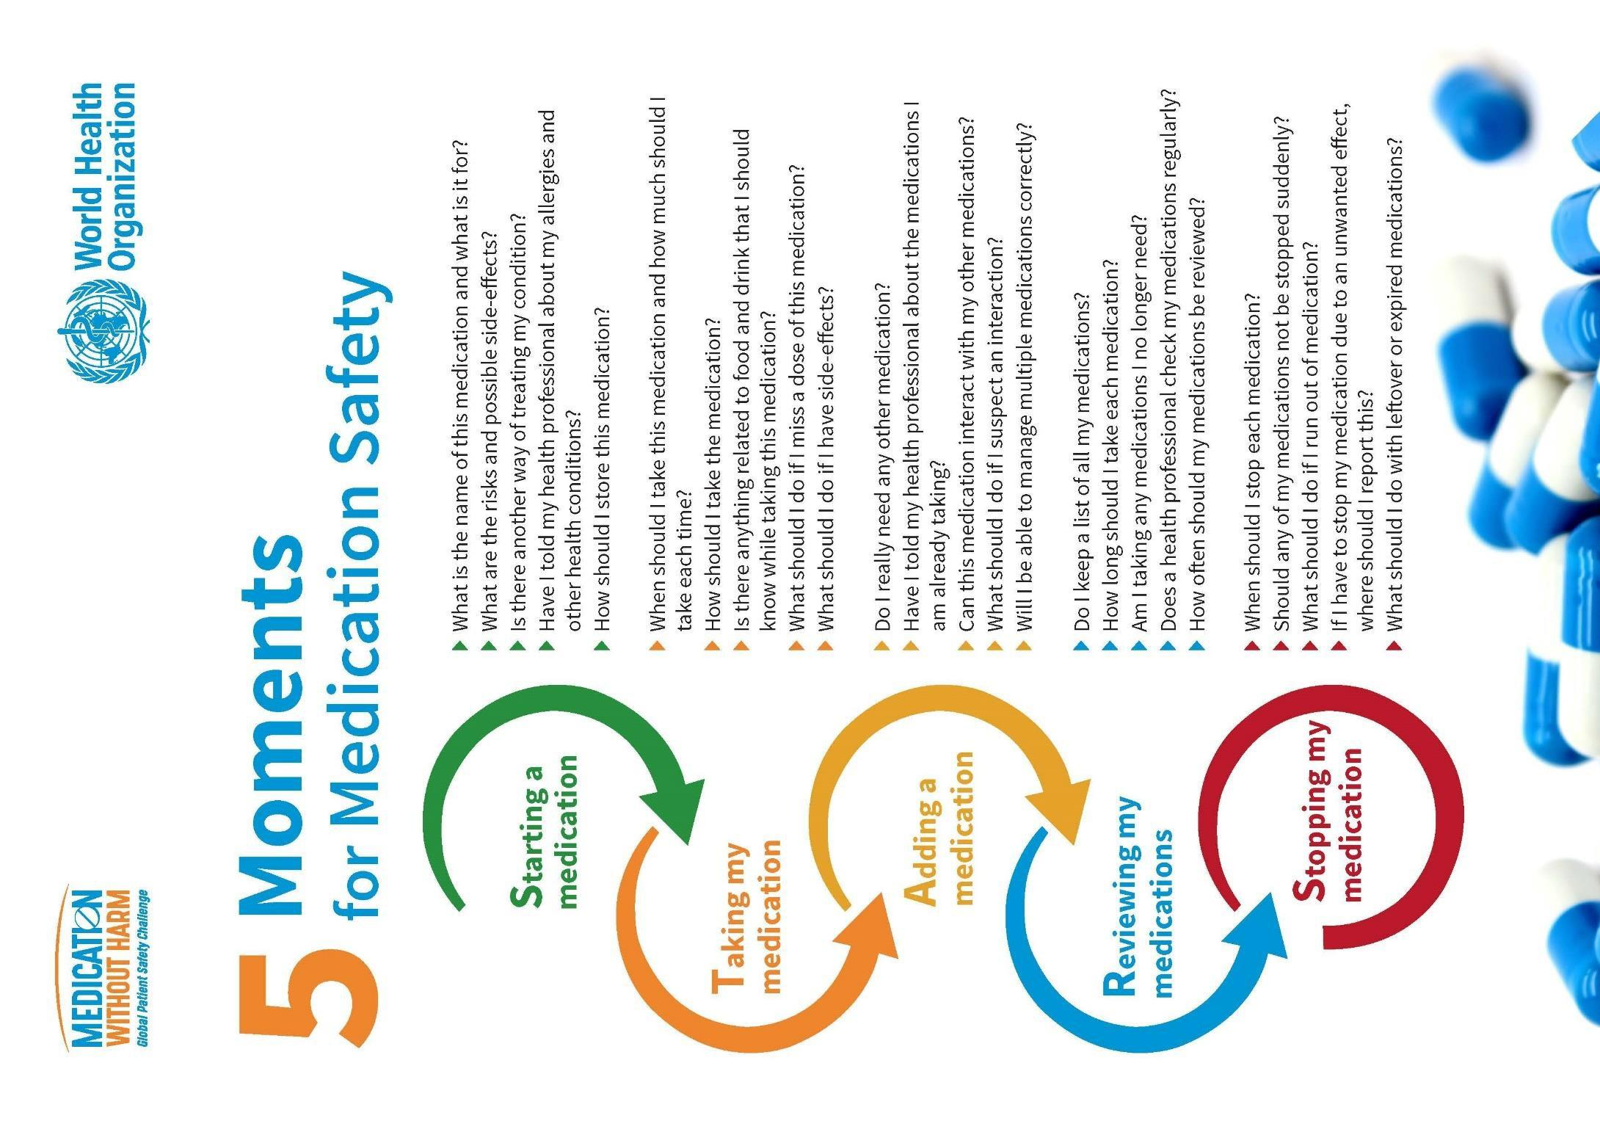

NCAD© UCD 2020/2021 For Revision by CASC 2021
Stage 2 Practice Placement (1)

Medication | Medication | Dose/ Route | Frequency | Peak | Contraindications | Side- effects | Observed
Generic/Brand/Trade | Group and | Dose/ Route | Frequency | Action/ |  | Side- effects | administration
Name | Indications | Dose/ Route | Frequency | duration of | Cautions / Nursing | Side- effects | of medication
Choose medication |  | Dose/ Route | Frequency | action | Considerations | Side- effects
related to specific |  | Dose/ Route | Frequency | (If available) |  | Side- effects
clinical area |  | Dose/ Route | Frequency |  |  | Side- effects
1.
2.

3.

Student Signature: _____________ Date: ________ Preceptor/Registered Nurse Signature: _____________ Date:________
Stage 2 Practice Placement (2)

Medication | Medication | Dose/ Route | Frequency | Peak | Contraindications | Side- effects | Observed
Generic/Brand/Trade | Group and | Dose/ Route | Frequency | Action/ |  | Side- effects | administration
Name | Indications | Dose/ Route | Frequency | duration of | Cautions / Nursing | Side- effects | of medication
Choose medication |  | Dose/ Route | Frequency | action | Considerations | Side- effects
related to specific |  | Dose/ Route | Frequency | (If available) |  | Side- effects
clinical area |  | Dose/ Route | Frequency |  |  | Side- effects
1.
2.

3.

Student Signature: _____________ Date: ________ Preceptor/Registered Nurse Signature: _____________ Date:________

Stage 2 Practice Placement (3)

Medication | Medication | Dose/ Route | Frequency | Peak | Contraindications | Side- effects | Observed
Generic/Brand/Trade | Group and | Dose/ Route | Frequency | Action/ |  | Side- effects | administration
Name | Indications | Dose/ Route | Frequency | duration of | Cautions / Nursing | Side- effects | of medication
Choose medication |  | Dose/ Route | Frequency | action | Considerations | Side- effects
related to specific |  | Dose/ Route | Frequency | (If available) |  | Side- effects
clinical area |  | Dose/ Route | Frequency |  |  | Side- effects
1.
2.

3.

Student Signature: _____________ Date: ________ Preceptor/Registered Nurse Signature: _____________ Date:________
Stage 2 Practice Placement (4)

Medication | Medication | Dose/ Route | Frequency | Peak | Contraindications | Side- effects | Observed
Generic/Brand/Trade | Group and | Dose/ Route | Frequency | Action/ |  | Side- effects | administration
Name | Indications | Dose/ Route | Frequency | duration of | Cautions / Nursing | Side- effects | of medication
Choose medication |  | Dose/ Route | Frequency | action | Considerations | Side- effects
related to specific |  | Dose/ Route | Frequency | (If available) |  | Side- effects
clinical area |  | Dose/ Route | Frequency |  |  | Side- effects
1.
2.

3.

Student Signature:_ Date: _ Preceptor Signature: _ Date:_
Stage 2 Practice Placement (5)

Medication | Medication | Dose/ Route | Frequency | Peak | Contraindications | Side- effects | Observed
Generic/Brand/Trade | Group and | Dose/ Route | Frequency | Action/ |  | Side- effects | administration
Name | Indications | Dose/ Route | Frequency | duration of | Cautions / Nursing | Side- effects | of medication
Choose medication |  | Dose/ Route | Frequency | action | Considerations | Side- effects
related to specific |  | Dose/ Route | Frequency | (If available) |  | Side- effects
clinical area |  | Dose/ Route | Frequency |  |  | Side- effects
1.
2.

3.

Student Signature: _____________ Date: ________ Preceptor/Registered Nurse Signature: _____________ Date:________

Stage 2 Practice Placement ()

Medication | Medication | Dose/ Route | Frequency | Peak | Contraindications | Side- effects | Observed
Generic/Brand/Trade | Group and | Dose/ Route | Frequency | Action/ |  | Side- effects | administration
Name | Indications | Dose/ Route | Frequency | duration of | Cautions / Nursing | Side- effects | of medication
Choose medication |  | Dose/ Route | Frequency | action | Considerations | Side- effects
related to specific |  | Dose/ Route | Frequency | (If available) |  | Side- effects
clinical area |  | Dose/ Route | Frequency |  |  | Side- effects
1.
2.

3.

Student Signature: _____________ Date: ________ Preceptor/Registered Nurse Signature: _____________ Date:________

Stage 2 Practice Placement ()

Medication | Medication | Dose/ Route | Frequency | Peak | Contraindications | Side- effects | Observed
Generic/Brand/Trade | Group and | Dose/ Route | Frequency | Action/ |  | Side- effects | administration
Name | Indications | Dose/ Route | Frequency | duration of | Cautions / Nursing | Side- effects | of medication
Choose medication |  | Dose/ Route | Frequency | action | Considerations | Side- effects
related to specific |  | Dose/ Route | Frequency | (If available) |  | Side- effects
clinical area |  | Dose/ Route | Frequency |  |  | Side- effects
1.
2.

3.

Student Signature: _____________ Date: ________ Preceptor/Registered Nurse Signature: _____________ Date:________

Stage 3 Practice Placement (1)

Medication | Medication | Dose/ Route | Frequency | Peak | Contraindications | Side- effects | Observed
Generic/Brand/Trade | Group and | Dose/ Route | Frequency | Action/ |  | Side- effects | administration
Name | Indications | Dose/ Route | Frequency | duration of | Cautions / Nursing | Side- effects | of medication
Choose medication |  | Dose/ Route | Frequency | action | Considerations | Side- effects
related to specific |  | Dose/ Route | Frequency | (If available) |  | Side- effects
clinical area |  | Dose/ Route | Frequency |  |  | Side- effects
1.
2.

3.

Student Signature: _____________ Date: ________ Preceptor/Registered Nurse Signature: _____________ Date:________

Stage 3 Practice Placement (2)

Medication | Medication | Dose/ Route | Frequency | Peak | Contraindications | Side- effects | Observed
Generic/Brand/Trade | Group and | Dose/ Route | Frequency | Action/ |  | Side- effects | administration
Name | Indications | Dose/ Route | Frequency | duration of | Cautions / Nursing | Side- effects | of medication
Choose medication |  | Dose/ Route | Frequency | action | Considerations | Side- effects
related to specific |  | Dose/ Route | Frequency | (If available) |  | Side- effects
clinical area |  | Dose/ Route | Frequency |  |  | Side- effects
1.
2.

3.

Student Signature: _____________ Date: ________ Preceptor/Registered Nurse Signature: _____________ Date:______

Stage 3 Practice Placement (3)

Medication | Medication |  | Dose/ Route | Frequency | Peak | Contraindications | Side- effects | Observed
Generic/Brand/Trade | Group and |  | Dose/ Route | Frequency | Action/ |  | Side- effects | administration
Name | Indications |  | Dose/ Route | Frequency | duration of | Cautions / Nursing | Side- effects | of medication
Choose medication |  |  | Dose/ Route | Frequency | action | Considerations | Side- effects
related to specific |  |  | Dose/ Route | Frequency | (If available) |  | Side- effects
clinical area |  |  | Dose/ Route | Frequency |  |  | Side- effects
1.
2.

3.

Student Signature: _____________ Date: ________ Preceptor/Registered Nurse Signature: _____________ Date:________

Stage 3 Practice Placement (4)

Medication | Medication | Dose/ Route | Frequency | Peak | Contraindications | Side- effects | Observed
Generic/Brand/Trade | Group and | Dose/ Route | Frequency | Action/ |  | Side- effects | administration
Name | Indications | Dose/ Route | Frequency | duration of | Cautions / Nursing | Side- effects | of medication
Choose medication |  | Dose/ Route | Frequency | action | Considerations | Side- effects
related to specific |  | Dose/ Route | Frequency | (If available) |  | Side- effects
clinical area |  | Dose/ Route | Frequency |  |  | Side- effects
1.
2.

3.

Student Signature: _____________ Date: ________ Preceptor/Registered Nurse Signature: _____________ Date:________

Stage 3 Practice Placement (5)

Medication | Medication | Dose/ Route | Frequency | Peak | Contraindications | Side- effects | Observed
Generic/Brand/Trade | Group and | Dose/ Route | Frequency | Action/ |  | Side- effects | administration
Name | Indications | Dose/ Route | Frequency | duration of | Cautions / Nursing | Side- effects | of medication
Choose medication |  | Dose/ Route | Frequency | action | Considerations | Side- effects
related to specific |  | Dose/ Route | Frequency | (If available) |  | Side- effects
clinical area |  | Dose/ Route | Frequency |  |  | Side- effects
1.
2.

3.

Student Signature: _____________ Date: ________ Preceptor/Registered Nurse Signature: _____________ Date:________

Stage 3 Practice Placement ()

Medication | Medication | Dose/ Route | Frequency | Peak | Contraindications | Side- effects | Observed
Generic/Brand/Trade | Group and | Dose/ Route | Frequency | Action/ |  | Side- effects | administration
Name | Indications | Dose/ Route | Frequency | duration of | Cautions / Nursing | Side- effects | of medication
Choose medication |  | Dose/ Route | Frequency | action | Considerations | Side- effects
related to specific |  | Dose/ Route | Frequency | (If available) |  | Side- effects
clinical area |  | Dose/ Route | Frequency |  |  | Side- effects
1.
2.

3.

Student Signature: _____________ Date: ________ Preceptor/Registered Nurse Signature: _____________ Date:________

Stage 3 Practice Placement ()

Medication | Medication | Dose/ Route | Frequency | Peak | Contraindications | Side- effects | Observed
Generic/Brand/Trade | Group and | Dose/ Route | Frequency | Action/ |  | Side- effects | administration
Name | Indications | Dose/ Route | Frequency | duration of | Cautions / Nursing | Side- effects | of medication
Choose medication |  | Dose/ Route | Frequency | action | Considerations | Side- effects
related to specific |  | Dose/ Route | Frequency | (If available) |  | Side- effects
clinical area |  | Dose/ Route | Frequency |  |  | Side- effects
1.
2.

3.

Student Signature: _____________ Date: ________ Preceptor/Registered Nurse Signature: _____________ Date:________

Part 2: Anaphylaxis (To be completed before end of Stage 2)

Anaphylaxis is a severe, life-threatening, generalised or systemic hypersensitivity reaction.

  - How would you recognise a person has had a reaction to a drug?

  - What are the key principles of management of anaphylaxis?

  - What drugs are commonly used in the treatment of anaphylaxis and what dosages are given?

Part 3A: Calculations: (To be completed before end of Stage 2)

Converting a larger unit of weight, measure or volume to a smaller one | Converting a smaller unit of weight, measure or volume to a larger one
Kilogram (kg) to gram (g) x 1000 | Gram (g) to kilogram (kg) ÷ 1000
Gram (g) to milligram (mg) x 1000 | Milligram (mg) to gram (g) ÷ 1000
Milligram (mg) to micrograms x 1000 | Microgram tomilligrams (mg)÷1000
Microgram to nanogram x 1000 | Nanogram to microgram ÷1000
Litre (l) to millilitre (ml) x 1000 | Millilitre (ml) to litre (l) ÷ 1000

Please calculate the following. Show how you achieved your answer. (Once completed refer to Part 5 to self-assess your answers) Metric Conversions:
A) B)
0.6 grams= mg
300microgram= mg

C) D)
0.125mg= micrograms
0.85mg= micrograms(mcg)

E) F)
356mg= grams
175 micrograms= mg
Part 3B: Answer the following questions in relation to the listed medications (Please refer to Part 6 to self-assess your answers)

- Mary is prescribed Betamethasone 12mg IM. Betamethasone is available in 4mg/ml vials.

  - How many vials will be required?
  - What volume will be administered in mls?
  - What syringe should you choose to administer
this medication? 1ml, 2ml or 5ml syringe.

- Mary is prescribed Eltroxin 0.25mg PO. 125mcg per tablet available.

  - How many tablets will be required?

- Mary is prescribed Pethidine 75mg IM 4-6hourly. Pethidine is available in 100mg/2ml vials

  - How many vials will be required?

  - What volume will be administered in mls?

  - What volume syringe should you choose to
administer this volume? 1ml, 2ml, 5ml

- MDA Schedule 2 Drugs (refer to local policy and NMBI guidance)

  - Name two regularly used MDA Schedule 2
Drugs used in general nursing care

  - Outline where MDA Schedule 2 Drugs should be stored?

  - Outline the documentation that should be completed during the preparation and administration of MDA Schedule 2 Drugs

Part 4: Medication Case Study
You are expected to complete a total of 4 case studies in Stages 2 & 3 inclusive of 1 whilst on your General Hospital Placement. One of these case studies must be completed on your longer placements. Please discuss the choice of placement and the patient with your preceptor and/or your CPC.
This case study will assist you to link your knowledge of medications to the care that you deliver to individuals. Identify an individual who is receiving medication and provide the information below.
Write a short case study identifying any pertinent information.

Medication Case Study 1

Gender:
Age: |  | Weight:
History include: Mental Health /Medical /Surgical History:
Present Diagnosis:
Medication Generic/Trade Name | Action of Medication |  | Side Effects/Nursing Considerations eg: checking blood pressure when patient is on an anti-hypertensive.
Calculate the dose of medication (if applicable)
Important Information:

Student Signature: _____________ Date: ________ Preceptor/Registered Nurse Signature: _____________ Date:________

Medication Case Study 2

Gender:
Age: |  | Weight:
History include: Mental Health /Medical /Surgical History:
Present Diagnosis:
Medication Generic/Trade Name | Action of Medication |  | Side Effects/Nursing Considerations eg: checking blood pressure when patient is on an anti-hypertensive.
Calculate the dose of medication (if applicable)
Important Information:

Student Signature: _____________ Date: ________ Preceptor/Registered Nurse Signature: _____________ Date:________

Medication Case Study 3

Gender:
Age: |  | Weight:
History include: Mental Health /Medical /Surgical History:
Present Diagnosis:
Medication Generic/Trade Name | Action of Medication |  | Side Effects/Nursing Considerations eg: checking blood pressure when patient is on an anti-hypertensive.
Calculate the dose of medication (if applicable)
Important Information:

Student Signature: _____________ Date: ________ Preceptor/Registered Nurse Signature: _____________ Date:________
Medication Case Study 4
Gender:
Age: |  | Weight:
History include: Mental Health /Medical /Surgical History:
Present Diagnosis:
Medication Generic/Trade Name | Action of Medication |  | Side Effects/Nursing Considerations eg: checking blood pressure when patient is on an anti-hypertensive.
Calculate the dose of medication (if applicable)
Important Information:

Student Signature: _____________ Date: ________ Preceptor/Registered Nurse Signature: _____________ Date:________
Part 5: Answers to Part 3A

A=600mgs B=0.3mg
C=850 micrograms D=125mcg E=0.175mg
F=0.356grams

Part 6: Answers to Part 3B

1.
a. =3
b. =3mls
c. 5ml syringe

2.
a. 2 tablets

3.
- 1 vial
- 1.5mls
- 2ml syringe

Suggested reading:
Berman, A. and Synder, S. (2012) Kozier & Erb's fundamentals of Nursing: Concepts, Process and Practice. 9th edn., New Jersey: Pearson Prentice Hall.

Brady, A., Malone, A. and Fleming, S. (2009) ‘A literature review of the individual and systems factors that contribute to medication errors in
nursing practice’, Journal of Nursing Management, 17, pp.679- 697.

Dougherty, L., Lister, S., and West-Oram A. (eds) (2015) The Royal Marsden Hospital Manual of Clinical Nursing Procedures. 9th edn., Oxford: Wiley Blackwell Publishing.

Drach-Zahavy, A. and Pud, D. (2010) ‘Learning mechanisms to limit medication administration errors’, Journal of Advanced Nursing, 66(4), pp.794-805.

Gatford,D.J; Philips, N.(2016) Nursing Calculations, Elsevier, London

Health Information and Quality Authority (2015) Medicines Management Guidance. Dublin: Health Information and Quality Authority

Health Products Regulatory Authority (2014) Safety Information. Available online: http://www.hpra.ie/homepage/medicines/safety- information

Jones, S.W. (2009) ‘Reducing medication administration errors in nursing practice’, Nursing Standard, 23 (50), pp40-46. Nursing and Midwifery Board of Ireland (2015) Scope of Nursing and Midwifery Practice Framework. Dublin: NMBI.
Nursing and Midwifery Board of Ireland (2018) Standards for Registered Nurses and Midwives on Medication Administration [Draft]. Dublin: NMBI.

Reid-Searl, K., Moxham, L. and Happell, B. (2010) ‘Enhancing patient safety: The importance of direct supervision for avoiding medication errors and near miss by undergraduate nursing students’, International Journal of Nursing Practice, 16, pp.225-232.

Starkings, S & Krause, L. (2018) Passing Calculations Tests in Nursing, 3rd edn., London: SAGE Publication Ltd.

World Health Organizations (2019) 5 Moments for medication safety, Available at: https://www.who.int/patientsafety/medication- safety/5moments/en/ (Accessed: 09th October, 2019)

Useful websites
Nursing and Midwifery Board of Ireland (2018) Guidance to Nurses and Midwives on Medication Management. Available at: https://www.nmbi.ie/Standards-Guidance/Medicines-Management (Accessed 14 August 2018)

Drug calculations quiz page (page (2018) Available at :http://www.testandcalc.com/quiz/index.asp (Accessed 14 August 2018) Dosagehelp.com(2018) Availableonlineat: http://www.dosagehelp.com/(Accessed: 30th August 2018)

Queens University Belfast, Numeracy Skills for Drug Calculations, Available at: https://www.qub.ac.uk/elearning/public/NumeracySkillsforDrugCalculations/(Accessed: 09th October, 2019)

Drug calculations quiz page (page (2018) Available at:http://www.testandcalc.com/quiz/index.asp (Accessed 14 August 2018)

World Health Organizations (2019) 5 Moments for medication safety, Available at: https://www.who.int/patientsafety/medication- safety/5moments/en/ (Accessed: 09th October, 2019)

